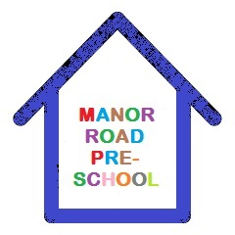

List of Consumables

This is the list of consumables we ask for a voluntary contribution of £2 a session during your child’s funded sessions at Manor Road Pre-School, the funding we receive for our funded children cannot be used for these items, so any contribution is very much appreciated and this amount will be added to your termly invoice.

Snack Foods to include;
Cereals, Breadsticks, Crackers, Cheese, Fruit, Vegetables

Personal Hygeine;
Nappy Wipes, Nappy Cream, Toilet Rolls, Wipes, Tissues, Bottom Wipes, Suncream, Soap, Hand Towels.

Cleaning Products;
Toilet Cleaner, Anti bacterial Sprays, Washing up Liquid, Cloths, Disenfectant, Bleach.

Extra Curricular Activities;
e.g Musical Visits, Butterfly Hatching

Obviously this list is just some of the items we have to purchase on a weekly basis for our children and is not included in the funding.

Manor Road PreSchool United Reformed Church, Manor Road, Rusthall, Kent
TN4 8UD
Ofsted 127365 Charity Number:102935

