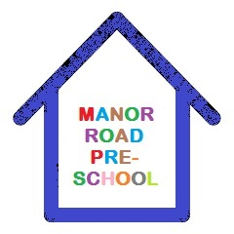

Fundraising Policy

We are a committee run pre-school and welcome our parents to join the committee and help raising funds for our children.
Our committee organise events, e.g. cake sales, sponsored walks and many other events that our families can join in and raise money towards special events, equipment, snacks and many other consumables we are unable to use Government funding for.
When you apply for a place at Manor Road Pre-School we will explain the reasons for asking for a voluntary contribution, of course there is no obligation to pay this and any amount is very much appreciated, a list of the consumables will be given to you when you join us.

The consumable list is on website for you to see

Signed : Manor Road Committee

Date : April 2026

